**Mini Project Synopsis**

**On**

**“Virtual Personal Assistant Using Speech Recognition”**



**SUBMITTED BY**

321910306039 (Y.krishnakaanth reddy)

321910306038 (K.Vishnu)

321910306008 (K.Pramod Reddy)

321910306058 (R.Prasanna Kumar Reddy)

321910306041(C.Sai sumanth)

Department of Computer Science and Engineering

SESSION: 2022 - 2023

*Under the guidance of*

|  |  |  |
| --- | --- | --- |
|  | Guide Name: Prof. DAYANAND LAL N  ------------------------  Designation : PHD |  |

**DEPARTMENT OF COMPUTER SCIENCE AND ENGINEERING**

**DEPT. OF CSE, SCHOOL OF TECHNOLOGY (GST),**

**GITAM UNIVERSITY (DEEMED TO BE UNIVERSITY)**

**BENGALURU, KARNATAKA, INDIA**

**Aim of the Project**

To Develop an application named "Lexi" which provides voice-based recognition for the physically disabled community.

**Problem Definition**

* The Idea is to build an Application, that works with Human voice based recognition which directly helps physically disabled community.
* In recent years there has been many invention with several hardware devices to help physically disabled community.
* Computer based systems has provided enormous support to differently abled personalities among which some of them are SIRI. Alexa, Etc.

# Hardware and software requirements:

**Hardware:**

* RAM
* Microphone

**Software:**

* Windows OS
* Internet
* Python interpreter’
* Integrated development Environment

Software Life Cycle Model

We will use the “**Iterative Waterfall Mode**l” for the development of **“Lexi-The Voice Assistant”.**

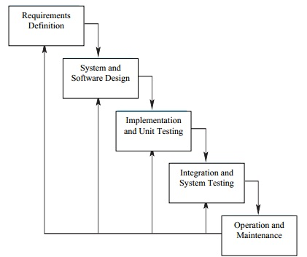

Figure: Iterative Waterfall Model

GANTT CHART

**Feasibility Study**

**Requirement Analysis**

**Design**

**Coding**

**Testing & Integration**

**Project Report**